
INDIAN STOCK MARKET ANALYSIS REPORT
L&T | BHEL | Power Grid Corporation of India


1. Introduction
This report provides a clear and easy-to-understand analysis of three major Indian infrastructure and energy stocks: Larsen & Toubro (L&T), Bharat Heavy Electricals Ltd (BHEL), and Power Grid Corporation of India. All three benefit from India's infrastructure and energy investment cycle.

We examine each across four key parameters:
- Price Trends — How the stock has moved over the past year
- P/E Ratio — Whether the stock appears cheap or expensive
- Market Capitalisation — The total market size of the company
- Recent News & Performance — What's happening right now

2. Quick Comparison Snapshot (June 2026)
Metric | L&T | BHEL | Power Grid
Current Price (₹) | ~4,076 | ~409 | ~291
52-Week High (₹) | 4,440 | 424.90 | 324.95
52-Week Low (₹) | 3,288 | 205.12 | 250.00
P/E Ratio | ~29–35x | ~92x | ~17x
P/B Ratio | ~5.1x | ~5.3x | ~2.7x
Market Cap (₹ Cr) | ~5,60,000 | ~1,45,000 | ~2,70,000
1-Year Return | +10.7% | +60.4% | -1.4%
Dividend Yield | ~0.97% | ~0.2% | ~4.2%
Sector | Infrastructure / EPC | Heavy Eng. / PSU | Power Transmission

3. Visual Analysis — Charts

3.1 Market Capitalisation Comparison
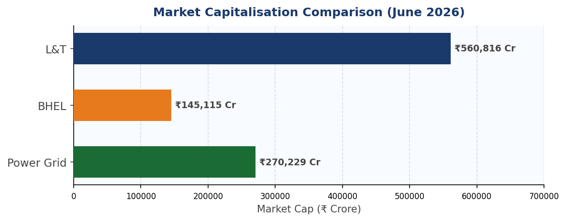
Chart 1 — Market Cap Comparison (₹ Crore) | June 2026
L&T dominates with a market cap more than double that of Power Grid, and almost 4x that of BHEL. Size reflects L&T's diversified conglomerate nature vs. the more focused government-owned enterprises.

3.2 P/E Ratio — Cheap or Expensive?
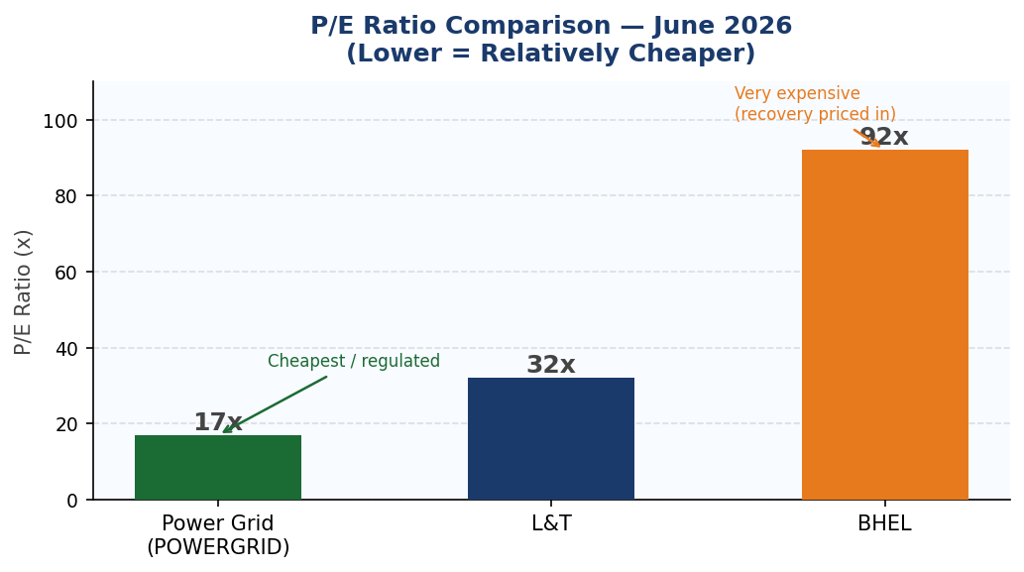
Chart 2 — P/E Ratio Comparison | June 2026
Power Grid is the cheapest at ~17x — fitting for a regulated utility with stable, predictable income. L&T trades at a moderate ~32x, reflecting growth expectations. BHEL's sky-high ~92x P/E is a 'recovery bet' — the market is pricing in explosive future earnings growth, not current earnings.

3.3 One-Year Stock Return
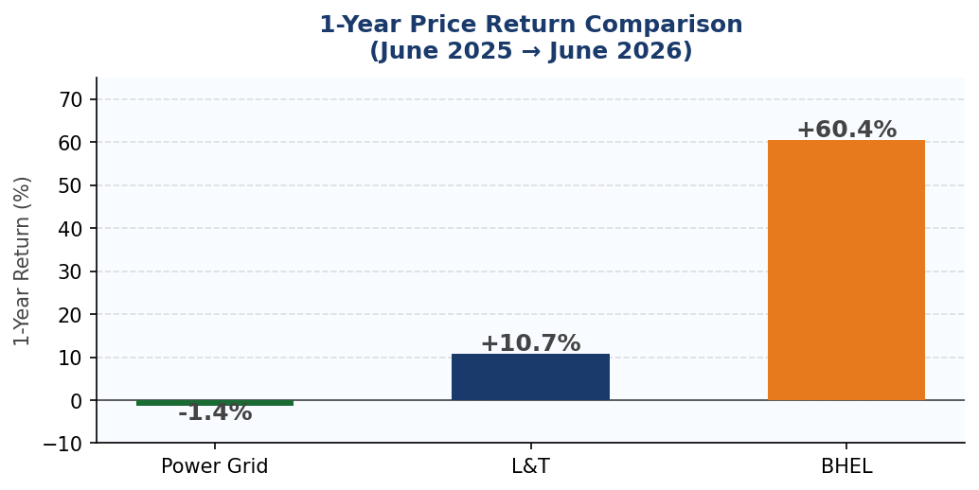
Chart 3 — 1-Year Price Return (%) | June 2025 to June 2026
BHEL has been the clear winner with a 60%+ return, driven by record profits and a massive order book. L&T delivered a solid 10.7%. Power Grid was essentially flat (-1.4%) — but delivered consistent dividend income of ~4.2% on top, making total returns more respectable.

3.4 52-Week Price Range
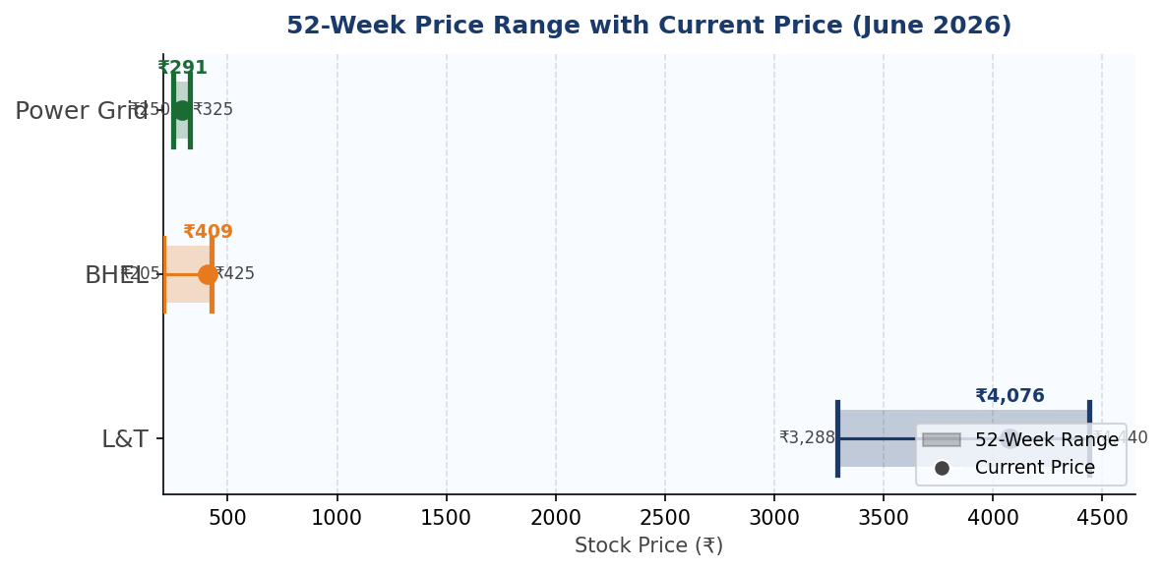
Chart 4 — 52-Week High / Low with Current Price | June 2026
This chart shows the full year range for each stock and where the current price sits within it. BHEL and L&T are trading near their highs, while Power Grid is closer to the middle of its range — suggesting relatively more room to recover for Power Grid.

3.5 Approximate 1-Year Price Trend (All Three Stocks)
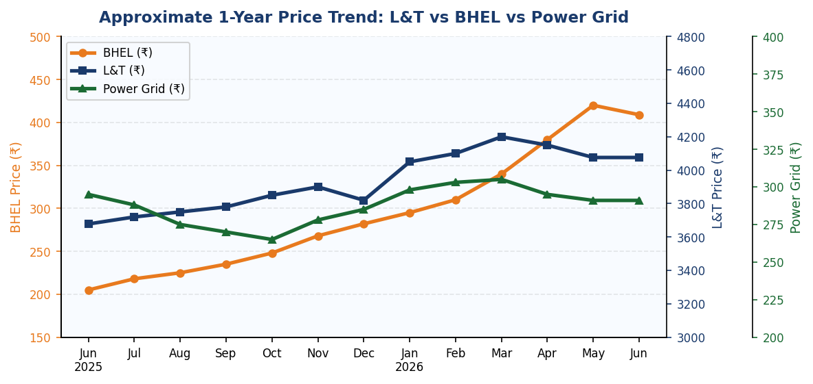
Chart 5 — Approximate Monthly Price Trend | June 2025 – June 2026
Note: L&T uses the right Y-axis (₹3,000–4,800), Power Grid uses the far-right axis (₹200–400), and BHEL uses the left axis (₹150–500). BHEL's near-vertical rise from mid-2025 stands out clearly, while Power Grid remained largely stable and L&T showed gradual appreciation.

3.6 FY2025-26 Revenue vs Net Profit
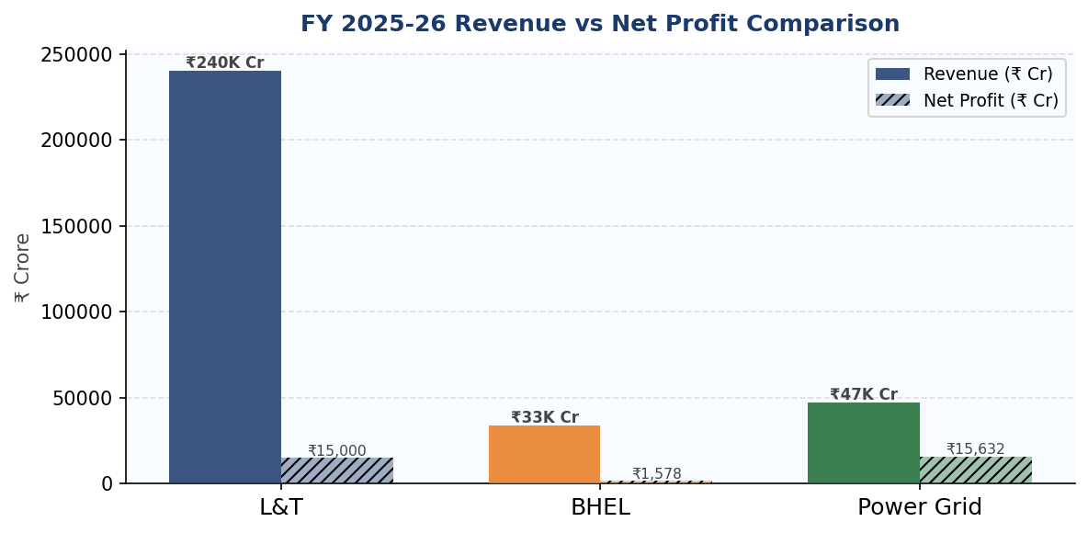
Chart 6 — FY26 Revenue (solid) vs Net Profit (hatched) in ₹ Crore
L&T's scale is unmatched in revenue (~₹2.4 lakh Crore consolidated). Power Grid and BHEL are smaller in revenue but Power Grid punches far above its weight in profitability — its ₹15,632 Cr net profit nearly matches L&T's despite much lower revenue, thanks to its high-margin regulated business model.

4. L&T — Larsen & Toubro (NSE: LT)
India's largest engineering conglomerate (est. 1938). Spans EPC construction, IT, defence manufacturing and financial services across 50+ countries.

Key Financials & Metrics
Parameter | Value
Current Price | ₹4,076
52-Week Range | ₹3,288 – ₹4,440
Market Cap | ~₹5,60,000 Crore
P/E Ratio | ~29–35x
EPS (FY26) | ₹116.93
1-Year Return | +10.7%
Dividend Yield | ~0.97%

Recent Highlights
- Won largest-ever domestic metals order from JSW Steel (₹10,000–15,000 Cr)
- Defence partnership with General Atomics (USA) for MALE drone manufacturing in India
- Mutual Fund holding at 20.5% — high institutional confidence
- 81st AGM scheduled June 5, 2026; new board composition underway

Verdict: Premium quality infrastructure franchise. Best for long-term growth investors. Priced fairly for its calibre.

5. BHEL — Bharat Heavy Electricals (NSE: BHEL)
India's largest government-owned heavy engineering company (est. 1964). Makes turbines, boilers, and power equipment for thermal, hydro and renewable energy plants.

Key Financials & Metrics
Parameter | Value
Current Price | ₹409
52-Week Range | ₹205 – ₹424.90
Market Cap | ~₹1,45,000 Crore
P/E Ratio | ~92x (recovery priced in)
FY26 Revenue | ₹33,782 Crore (+19% YoY)
Q4 FY26 Profit Growth | +156% YoY
Order Book | ₹2,40,000 Crore

Recent Highlights
- All-time high of ₹424.90 hit on May 14, 2026 — spectacular turnaround
- Q4 FY26 net profit surged 156% year-on-year — among the best results in a decade
- BSE Power Index rose 24% in 2 months; BHEL was a top beneficiary
- Potential new order of ₹8,000–10,000 Crore in pipeline
- Yadadri Thermal Power Station (4,000 MW) 3rd unit commissioned

Verdict: High-risk, high-reward PSU turnaround. Best for aggressive investors with 2–3 year outlook. Volatility expected.

6. Power Grid Corporation (NSE: POWERGRID)

India's largest electricity transmission utility, owned by Govt. of India (est. 1989). Carries high-voltage power across the national grid. Headquartered in Gurugram.

Key Financials & Metrics
Parameter | Value
Current Price | ₹291
52-Week Range | ₹250 – ₹324.95
Market Cap | ~₹2,70,000 Crore
P/E Ratio | ~17x
FY26 Net Profit | ₹15,632 Crore (+9.7% YoY)
1-Year Return | -1.4% price + 4.2% dividend
Dividend Yield | ~4.2%

Recent Highlights
- Q4 FY26 net profit rose 9.74% to ₹4,546 Crore — steady and reliable
- Final dividend of ₹1.25/share approved; quarterly dividend ₹3.25/share already paid
- FY27 CapEx target set at ₹37,000 Crore — major grid expansion ahead
- 99.8% system availability — world-class reliability
- 765kV digital substation commissioned — cutting-edge technology

Verdict: The safest of three. Dividend compounder, predictable income, low P/E. Ideal for conservative and income-focused investors.

7. Conclusion & Investment Takeaway

All three companies represent different facets of India's infrastructure and energy boom:

Stock | Best For | Key Strength
L&T | Long-term growth investors | Diversified conglomerate, defence & infra tailwinds
BHEL | Aggressive / high risk appetite | PSU turnaround, 156% profit growth, ₹2.4L Cr order book
Power Grid | Conservative / income-seeking | 4.2% dividend, lowest P/E, regulated stable income

India's infrastructure super-cycle — powered by government capex in roads, railways, power, and defence — is the common thread. The key difference is speed vs. safety: BHEL is the sprinter, L&T is the marathon runner, Power Grid is the steady walker.

